CSC-202L Artificial Intelligence
Project Report
Section: A



Submitted By:
Syed Shayan Arshad 2023-CS-625
Adeel-Ur-Rehman 2023-CS-626
Hammad Khalid 2023-CS-637

Submitted To:
Mam. Shanfa
Dated: 4th May 2025

Department of Computer Science
University of Engineering and Technology Lahore, New Campus
1. Introduction
Air quality is a critical factor affecting public health and the environment. The Air Quality Index (AQI) is a standardized metric that quantifies air pollution levels based on various pollutants. This project aims to analyse air quality data using machine learning techniques to classify air quality into categories (e.g., Good, Moderate, Poor) and identify patterns through clustering. The primary objectives are:
- Classification: Predict the AQI category using K-Nearest Neighbors (KNN), Naive Bayes, and Random Forest algorithms.
- Clustering: Group similar air quality observations using the K-Means algorithm to uncover underlying patterns.
- Performance Evaluation: Assess model performance using metrics like Accuracy, Precision, Recall, and F1-Score.
- Improvement: Enhance model performance through preprocessing and feature engineering.
2. Dataset Selection and Description
Dataset Selection
The dataset used is an air quality dataset (air_quality_feature.csv) containing approximately 570,000 records. It includes temporal, spatial, and environmental features related to air quality across various cities. The dataset was chosen because:
- Relevance: It contains comprehensive air quality metrics (e.g., PM2.5, NO2, AQI) suitable for classification and clustering tasks.
- Size: With 570,000 records, it provides sufficient data for robust machine learning models.
- Diversity: It includes multiple pollutants, meteorological factors, and derived features, enabling detailed analysis.
Dataset Description
The dataset contains the following key columns:
- Temporal Features: Date, Weekday
- Spatial Features: City, Latitude, Longitude, Urban Density
- Pollutant Features: PM2.5, PM10, NO, NO2, NH3, CO, SO2, O3, Benzene, Toluene, Xylene
- Meteorological Features: Temperature, Humidity, Wind Speed, Atmospheric Pressure
- Derived Features: Volatility Index, O3_Rolling_Std, Pollution Index, Lat Long Interaction, PM Ratio, NOx
- Target Variable: AQI (numerical), AQI Bucket (categorical: Good, Satisfactory, Moderate, Poor, Very Poor, Severe)
The target variable AQI Bucket has six classes, making this a multi-class classification problem. The dataset's large size and variety of features make it ideal for both supervised (classification) and unsupervised (clustering) learning tasks.
3. Classification Methodology and Details
Three classification algorithms were implemented: K-Nearest Neighbors (KNN), Naive Bayes, and Random Forest. Below is a detailed explanation of each, including their working and implementation in the project.
3.1 K-Nearest Neighbors (KNN)
Working: KNN is a distance-based algorithm that classifies a data point by finding its k nearest neighbors (based on Euclidean distance) and assigning the majority class among them. It is simple but sensitive to feature scaling and noisy data.
Implementation:
- Preprocessing:
  - Encoded categorical variables (Weekday, City, AQI Bucket) using LabelEncoder.
  - Removed outliers using the Interquartile Range (IQR) method (1.5 * IQR bounds) for numerical features.
  - Imputed missing values with the mean using SimpleImputer.
  - Selected the top 20 features using SelectKBest with f_classif scoring.
  - Scaled features using StandardScaler.
  - Applied SMOTE to handle class imbalance.
- Model: Used KNeighborsClassifier with n_neighbors=3.
- Training: Split data into 80% training and 20% testing sets (train_test_split).
Parameters: The choice of k=3 is by iterating the KneighborsClassifiers in a loop from 1 to 20 to get the maximum accuracy.
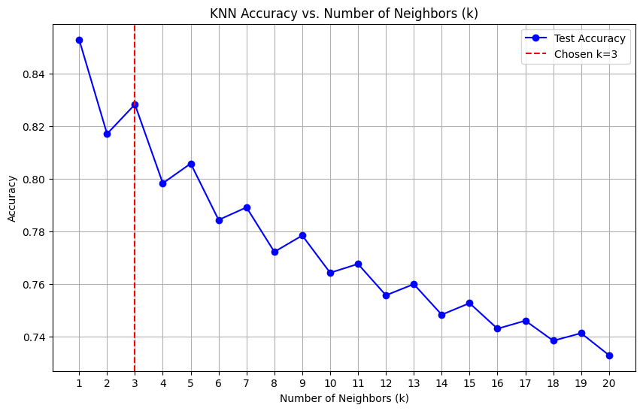
3.2 Naive Bayes
Working: Naive Bayes is a probabilistic algorithm based on Bayes' Theorem, assuming feature independence. It calculates the probability of each class given the features and selects the class with the highest probability. Gaussian Naive Bayes was used, assuming features follow a normal distribution.
Implementation:
- Preprocessing:
  - Filtered rows with non-null values and Imputed missing values with the median.
  - Removed outliers using a stricter IQR threshold (1.5 * IQR).
  - Reduced the dominant "Moderate" class to address imbalance.
  - Encoded AQI Bucket into numerical values (e.g., Poor: 1, Moderate: 2).
  - Scaled features using StandardScaler.
  - Applied PCA to retain 55% of variance, reducing dimensionality.
- Model: Used GaussianNB.
- Training: Split data into 80% training and 20% testing sets.
3.3 Random Forest
Working: Random Forest is an ensemble algorithm that builds multiple decision trees on random subsets of data and features, aggregating their predictions (majority voting for classification). It is robust to overfitting and handles imbalanced data well.
Implementation:
- Preprocessing: Same as KNN (IQR outlier removal, mean imputation, feature selection, scaling, SMOTE).
- Model: Used RandomForestClassifier with n_estimators=100 and random_state=42.
- Training: Split data into 80% training and 20% testing sets.
Parameters: The number of trees (n_estimators=100) was chosen as a balance between performance and computational efficiency.
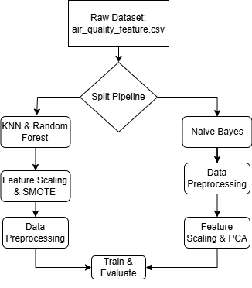
4. Clustering Methodology and Details
K-Means Clustering
Working: K-Means is an unsupervised algorithm that partitions data into k clusters by minimizing the within-cluster sum of squares (WCSS). It iteratively assigns points to the nearest cluster centroid and updates centroids until convergence.
Implementation:
- Preprocessing:
  - Copied the dataset and imputed missing values with the mean for numerical columns.
  - Selected only numerical features (e.g., PM2.5, NO2, Temperature).
  - Scaled features using StandardScaler to ensure equal contribution to distance calculations.
- Elbow Method:
  - Computed WCSS for k=1 to k=20 using KMeans with n_init=10 and random_state=0.
  - Plotted the Elbow Curve to identify the optimal k.
  - Chose k=6 based on the elbow point where WCSS reduction slowed.
- Clustering:
  - Applied KMeans with k=6 to the scaled numerical features.
  - Assigned cluster labels to the dataset.
- Visualization:
  - Plotted a scatter plot of PM2.5 vs. NO2, colored by cluster labels, to visualize cluster separation.
  - Included the Elbow Curve plot to justify the choice of k=6.
5. Performance Evaluation
The performance of the classification models was evaluated using Accuracy, Precision, Recall, and F1-Score.
Accuracy: Accuracy measures the proportion of correctly classified instances out of the total instances. It indicates how often the model predicts the correct AQI Bucket class overall.
Accuracy = $\frac{Total Number of Predictions}{Number of Correct Predictions}$ ​=> $\frac{TP+TN}{TP+TN+FP+FNs}$ ​
Precision: Precision measures the proportion of correctly predicted positive instances out of all instances predicted as positive for a given class.
Precision = $\frac{TP}{TP+FP}$
Recall: Recall measures the proportion of actual positive instances that were correctly predicted.
Recall = $\frac{TP}{TP+FN}$
F1-Score: The F1-Score is the harmonic mean of Precision and Recall, providing a single metric that balances both.
F1-Score = $\frac{Precision * Recall}{Precision + Recall}$
Performance Evaluation Results:
Model | Accuracy | Precision | Recall | F1-Score
KNN | 0.828 | 0.84 | 0.83 | 0.83
Naive Bayes | 0.82 | 0.80 | 0.82 | 0.78
Random Forest | 0.863 | 0.87 | 0.86 | 0.86

6. Visualizations
The following visualizations were used to analyze and present the results:
- Dataset Exploration:
  - Histogram of AQI Bucket to show class distribution.
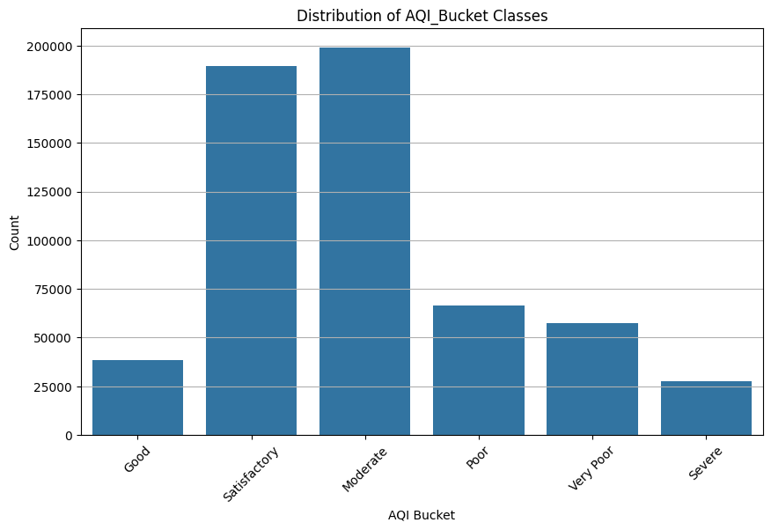
  - Boxplots of key features (e.g., PM2.5) before and after outlier removal (already generated).
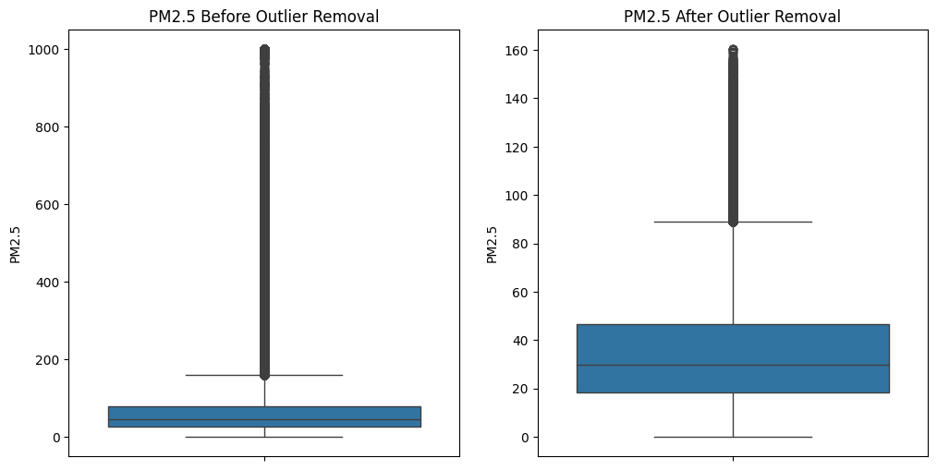
- Clustering:
  - Elbow Curve to determine the optimal number of clusters (k=6).
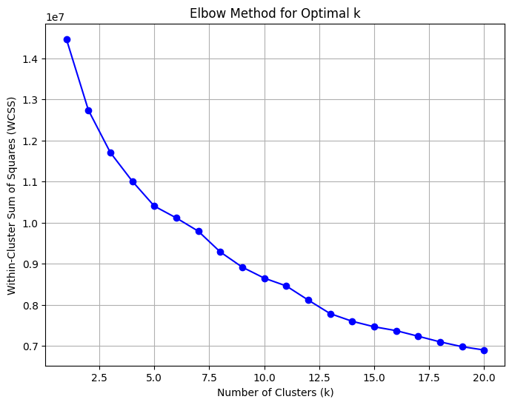
  - Scatter plot of PM2.5 vs. NO2 colored by cluster labels to visualize cluster separation.
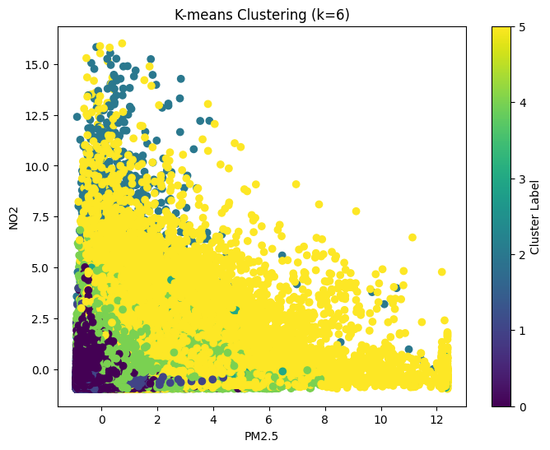
- Classification:
  - Confusion matrices for KNN, Naive Bayes, and Random Forest to show prediction accuracy per class.
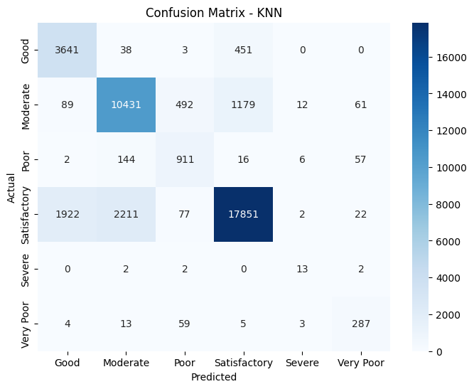
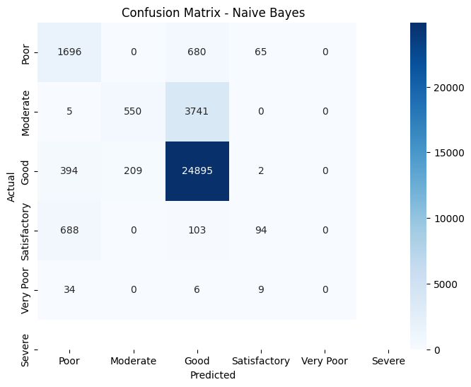
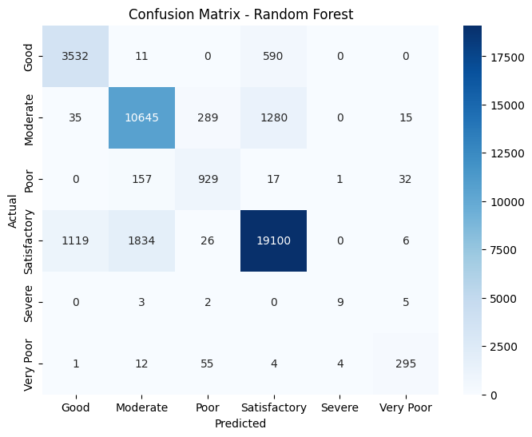
  - Bar plot comparing Accuracy, Precision, Recall, and F1-Score across models.
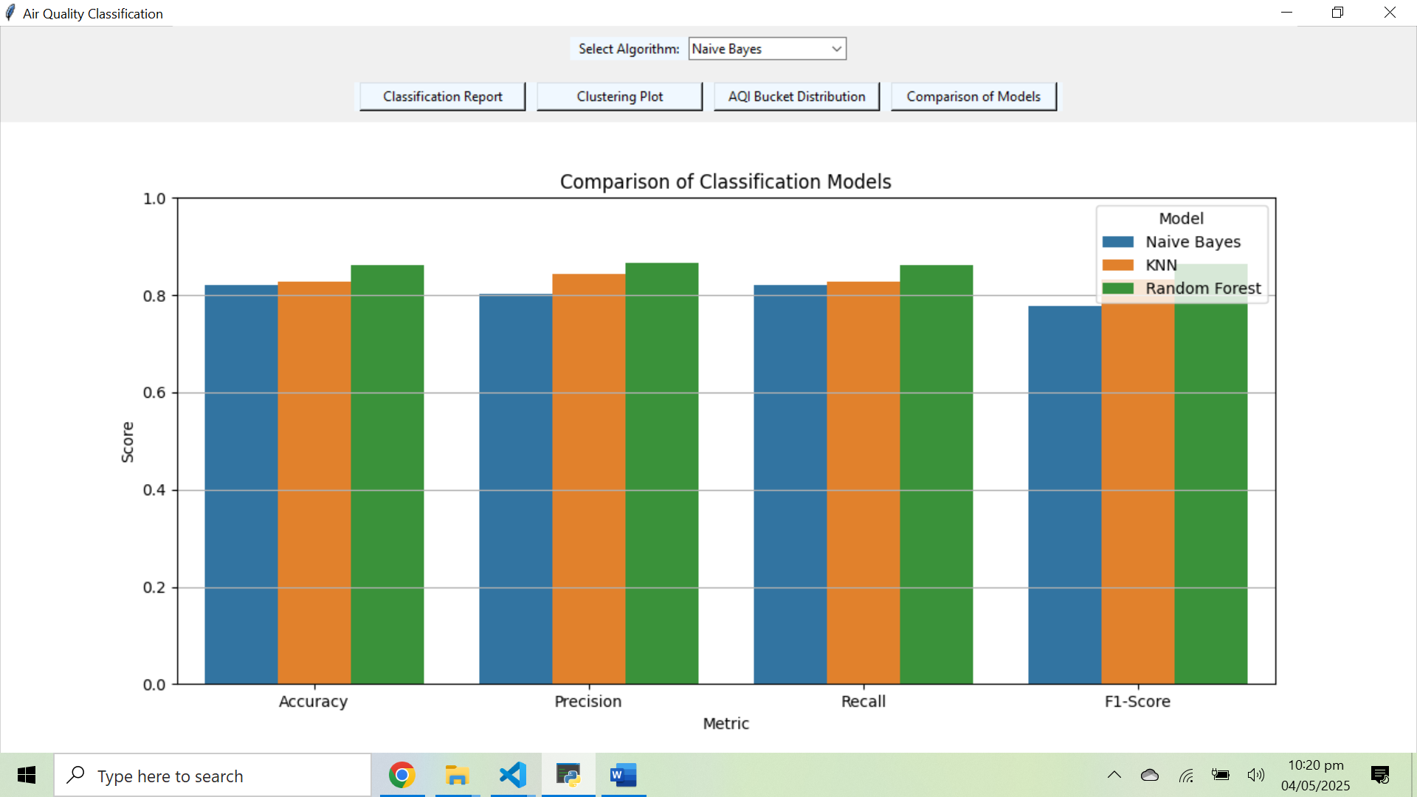
- Feature Selection:
  - Bar plot of feature importance scores from SelectKBest to highlight the top 20 features.
7. Comparison and Reason for Choosing Algorithms
Comparison
- KNN: Achieved moderate performance (Accuracy: 0.828) but was sensitive to minority classes and required careful preprocessing (scaling, feature selection).
- Naive Bayes: Had the good performance (Accuracy: 0.82) due to its assumption of feature independence and aggressive preprocessing (PCA, class reduction).
- Random Forest: Outperformed others (Accuracy: 0.863) due to its robustness to noise, ability to handle imbalanced data, and ensemble nature.
Reasons for Choosing Algorithms
The selection of Random Forest as third model for classification because:
- It handles imbalanced datasets well, which was critical given the skewed AQI Bucket distribution.
- It is robust to outliers and noise, reducing preprocessing overhead.
- It provides feature importance, aiding interpretability.
- It typically outperforms simpler models like KNN and Naive Bayes for complex datasets.
8. Efforts to Improve Results
The initial models (KNN and Random Forest) had lower accuracy due to basic preprocessing. Several improvements were made, as detailed below:
KNN and Random Forest
- Initial Approach: Used all 24 features with basic preprocessing (mean imputation, scaling). Accuracy was low due to outliers and irrelevant features.
- Improvements:
  - Outlier Removal: Applied IQR-based outlier removal (1.5 * IQR) for numerical features and reducing noise.
Classification Models | Accuracy (Before IQR) | Accuracy (After IQR)
KNN | 0.7860 | 0.8282
Naive Bayes | 0.6045 | 0.82
Random Forest | 0.8360 | 0.8620

  - Feature Selection: Reduced from 24 to 20 features using SelectKBest with f_classif, focusing on high-impact features like PM2.5, NO2, and Pollution_Index.
  - Class Imbalance: Applied SMOTE to oversample minority classes, improving performance on classes like "Very Poor" and "Severe"
Naive Bayes
- Initial Approach: Used basic preprocessing with median imputation. Performance was poor due to class imbalance and high dimensionality.
- Improvements:
  - Outlier Removal: Used a stricter IQR threshold (1.5 * IQR) to remove extreme values.
  - Class Reduction: Reduced the dominant "Moderate" class to balance the dataset, though this reduced overall data size.
  - Dimensionality Reduction: Applied PCA to retain 55% of variance, reducing feature correlation but potentially losing information.
  - Result: Accuracy improved to 0.82, and performance is same with KNN and Random Forest because of adding IQR.
Clustering (K-Means)
- Initial Approach: Applied K-Means with arbitrary k. Cluster quality was unclear without proper k selection.
- Improvements:
  - Elbow Method: Used the Elbow Curve to select k=6, ensuring meaningful clusters.
  - Scaling: Standardized numerical features to ensure equal contribution to clustering.
9. Conclusion
This project successfully applied machine learning to classify and cluster air quality data. Random Forest achieved the highest performance (Accuracy: 0.863), followed by KNN (0.828) and Naive Bayes (0.82). K-Means clustering with k=6 revealed meaningful patterns in pollutant distributions. Key improvements included outlier removal, feature selection, and SMOTE for classification, and the Elbow Method for clustering. The results demonstrate the effectiveness of ensemble methods like Random Forest for complex datasets and the importance of preprocessing in improving model performance.

